Linux commands Tast-2
1. Create user with name Techie and provide sudo access
$ sudo adduser Techie
$ sudo usermod -aG sudo Techie
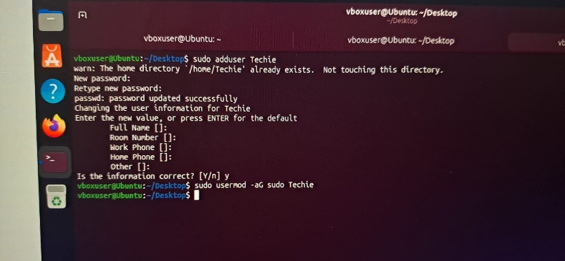
2. Navigate to the home directory
$ cd ~
3. Create a new directory
$ mkdir DevOps
4. List the contents of a directory
$ ls -l
5. Change the current directory
$ cd DevOps
6. Create a new empty file
$ touch file.txt
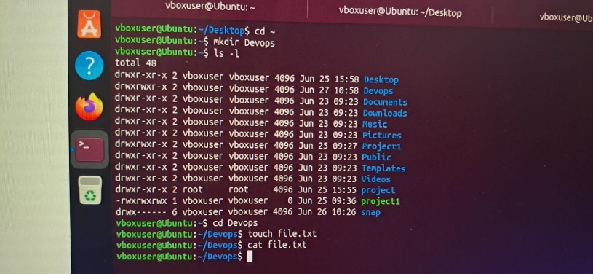
7. View the contents of a file
$ cat file.txt
8. Copy a file to another location
$ cp file.txt /tmp/

9. Move a file to another location
mv file1.txt /tmp/
10. Rename a file
mv oldfile.txt newfile.txt
11. Delete a file
rm file1.txt
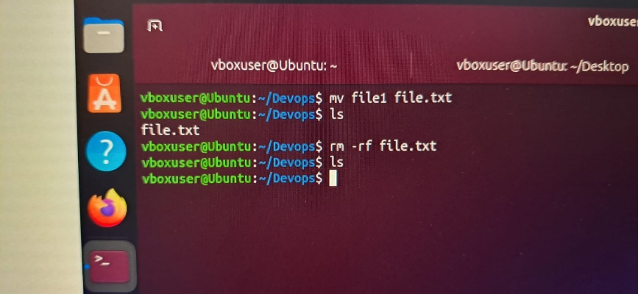
12. Grant or revoke permissions
Grant:
$ chmod 755 script.sh
Revoke:
$ chmod 644 script.sh
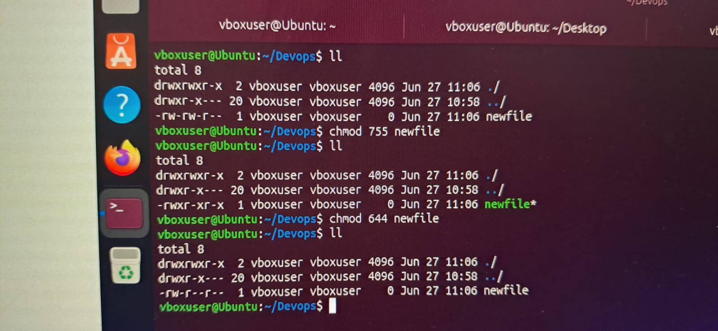
13. View current date and time
$ date
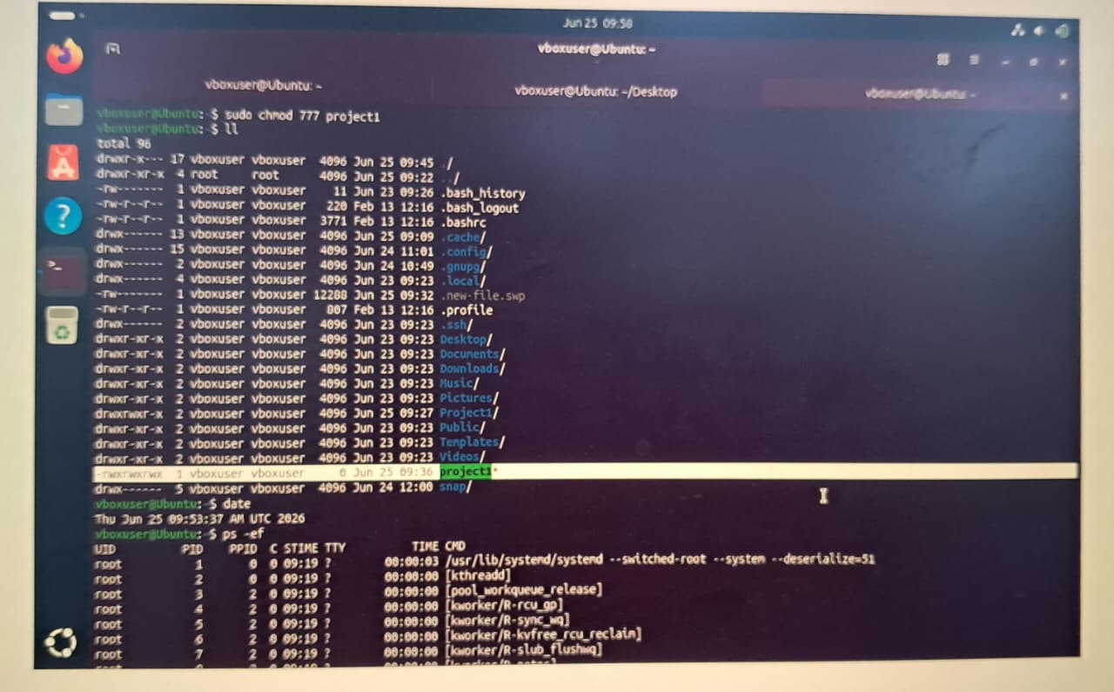

14. Check system uptime
$ uptime
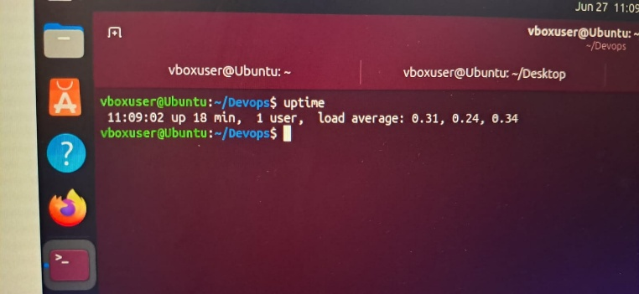
15. View running processes
$ ps -ef
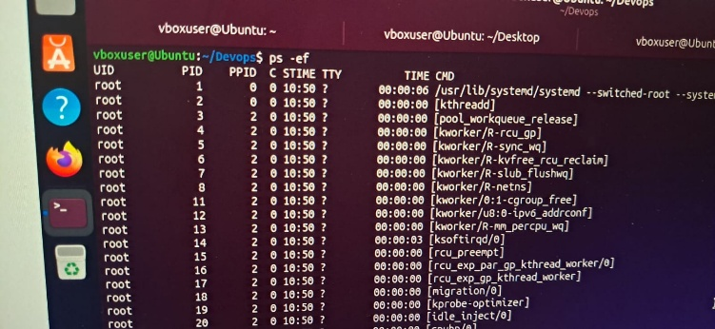
16. Kill a running process
$ kill -9 PID
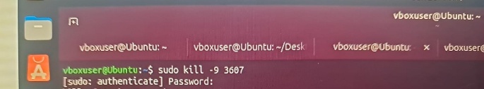
17. Install package using apt
$ sudo apt install nginx -y
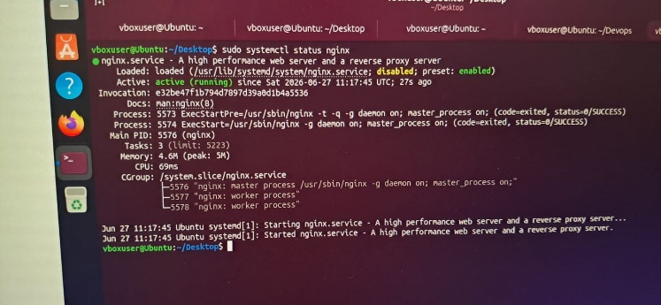
18. Update system packages
$ sudo apt update && sudo apt upgrade -y
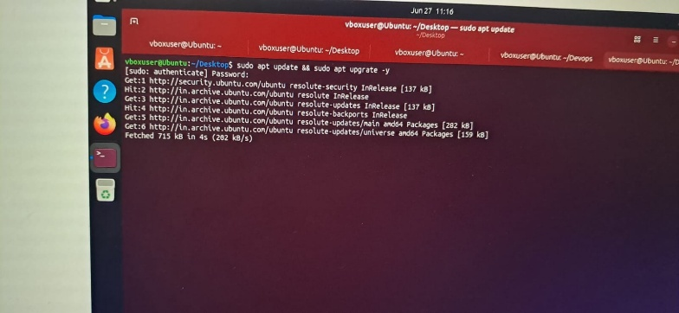
19. Create a symbolic link
$ ln -s /var/log/syslog syslog_li
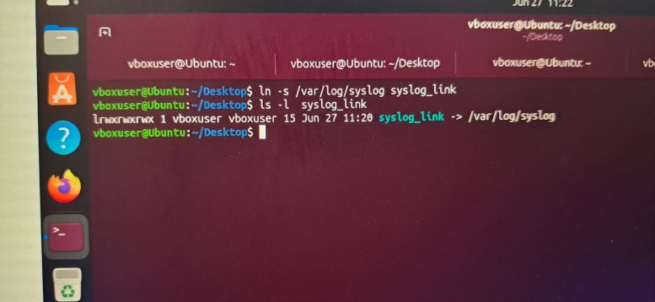
20. Search for files
$ find /home -name "*.txt"
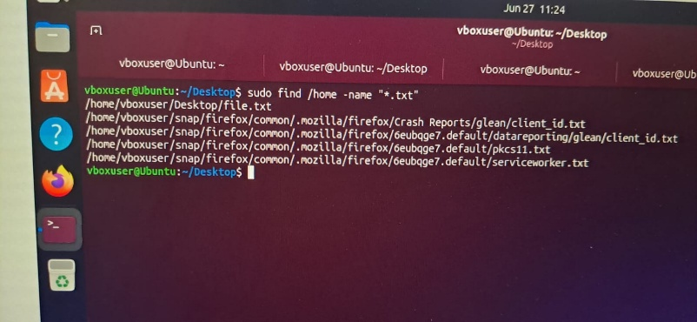
21. Compress and decompress files
Compress:
$ tar -czvf backup.tar.gz file1/
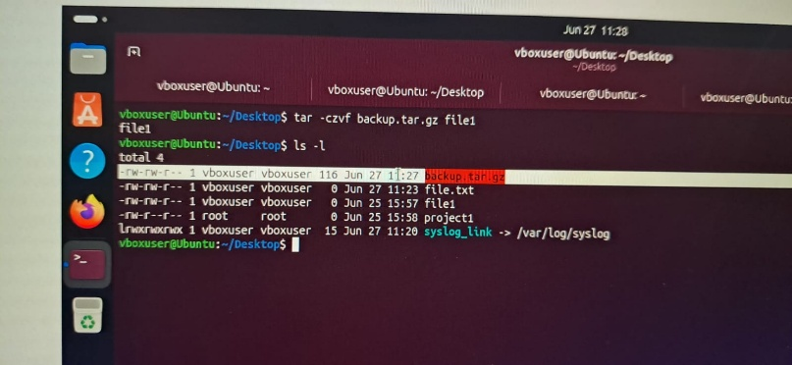

Extract:
$ tar -xzvf backup.tar.gz
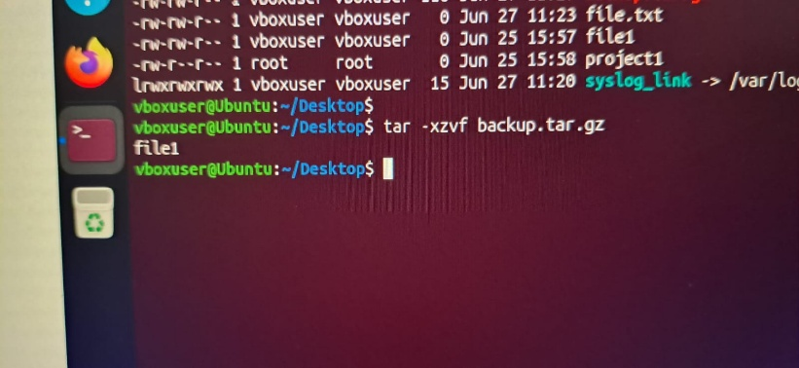
22. Monitor system resources
$ Top
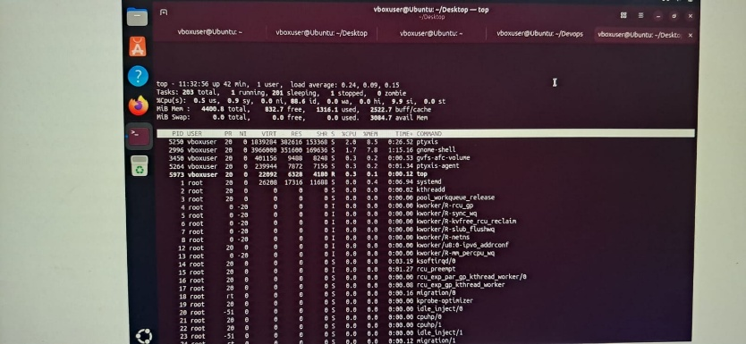
23. Create and manage user groups
Create Group:
$ sudo groupadd devops
Add User:
$ sudo usermod -aG devops Techie
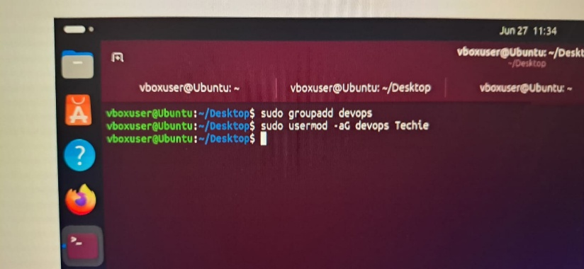

24. Set up SSH passwordless authentication
create user and grant Sudo permission
$ sudo adduser sarfaraz
$ sudo usermod -aG sudo sarfaraz
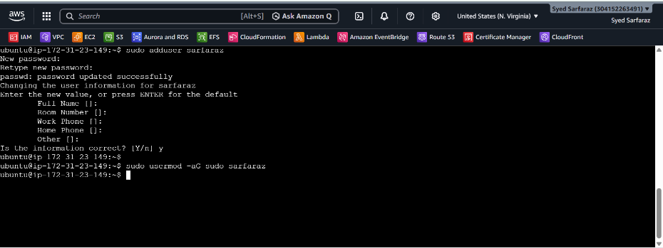
Set up SSH password less authentication
$ sudo visudo
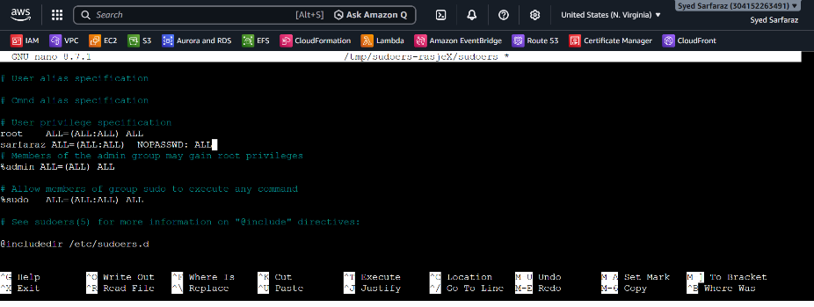
Allow ssh configreation
$ sudo vi /etc/ssh/sshd_config.d/60-cloudimg-settings.conf
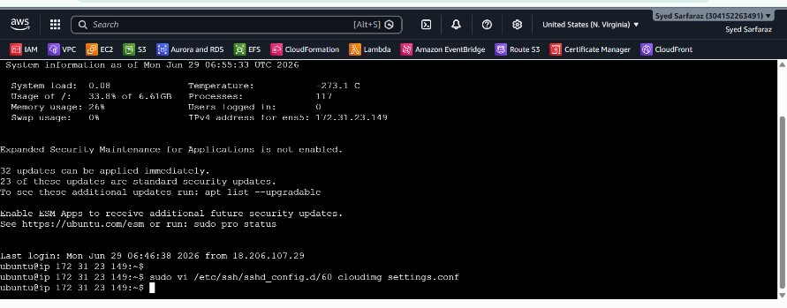

Switch User and create keygen
$ su – sarfaraz
$ ssh-keygen
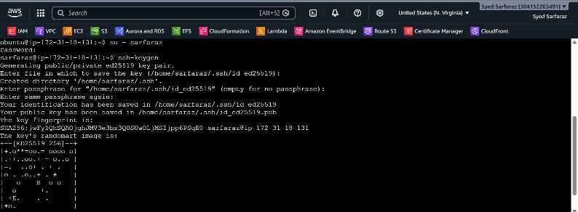
Configure Machine one to Machine two
$ ssh-copy-id sarfaraz@172.31.28.183
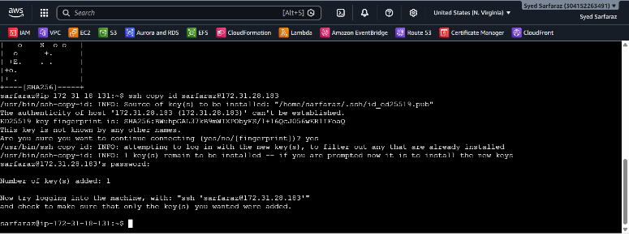
Now connet to Another machine with Password Authentication
$ ssh sarfaraz@172.31.28.183
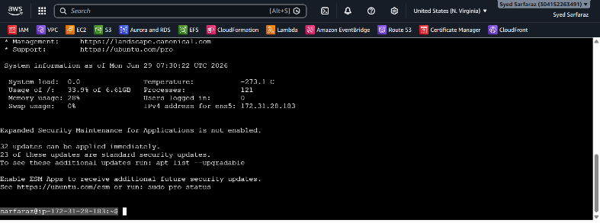

25. Monitor log files
$ tail -f /var/log/syslog
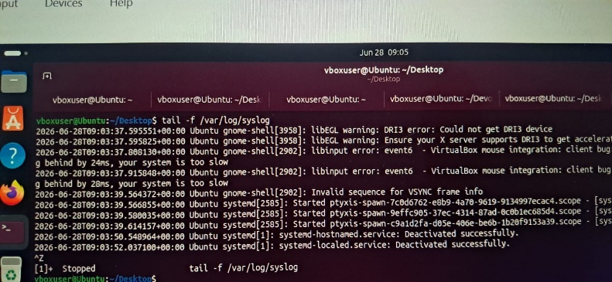
$ grep ERROR /var/log/syslog
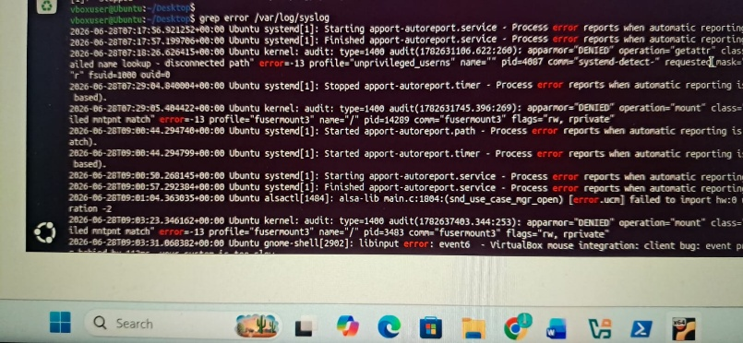

26. Setup Apache Web Server
$ sudo apt update
$ sudo apt install apache2 -y
$ sudo systemctl start apache2
$ sudo systemctl enable apache2
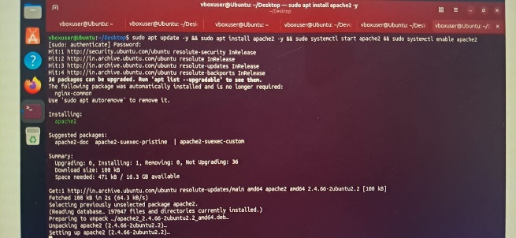
$ sudo systemctl status apache2
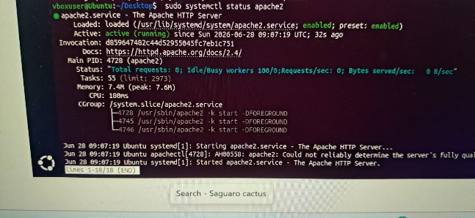
27. Configure and Secure MySQL Database
Install:
$ sudo apt install mysql-server -y
Check Status:
$ sudo systemctl status mysql
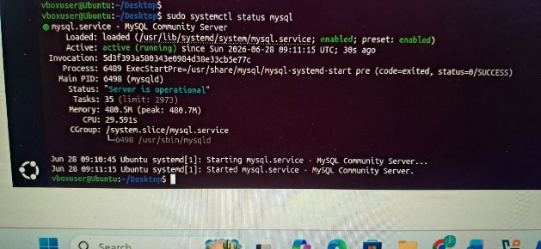

28. Setup Apache Tomcat Application Server
Install Java:
$ sudo apt install openjdk-17-jdk -y
Download Tomcat:
$ cd /tmp
$ wget https://downloads.apache.org/tomcat/tomcat-10/v10.1.42/bin/apache-tomcat-10.1.42.tar.gz
Extract: tar -xvzf apache-tomcat-10.1.42.tar.gz
$ sudo mv apache-tomcat-10.1.42 /opt/tomcat
Start Tomcat:
$ cd /opt/tomcat/bin
$ chmod +x *.sh
./startup.sh
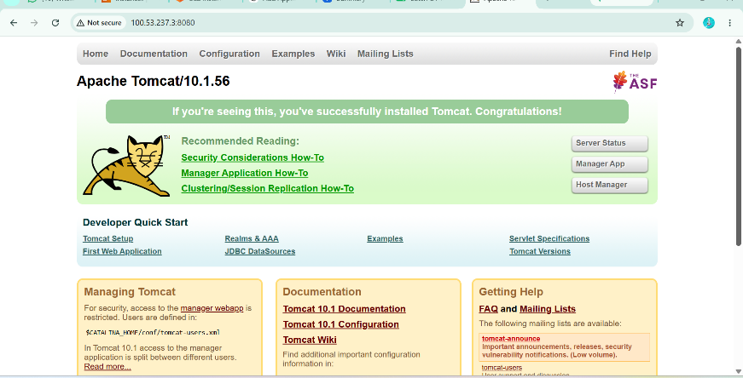
29. Create Tomcat Service File
$ sudo systemctl daemon-reload
$ sudo systemctl enable tomcat
$ sudo systemctl start tomcat
$ sudo systemctl status tomcat

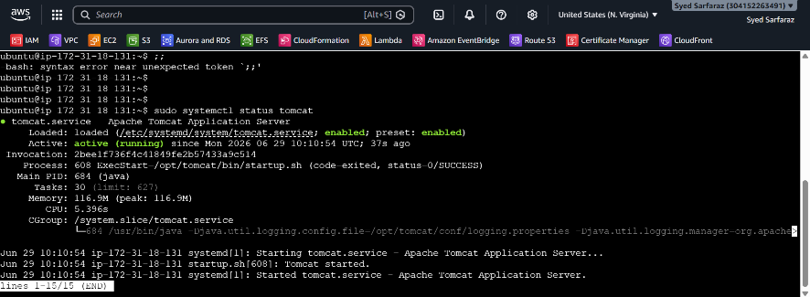
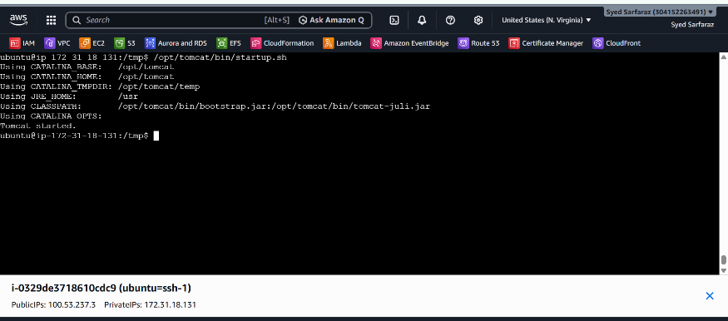

30. Print specific columns from a file
$ awk -F',' '{print $1,$3}' employees.csv
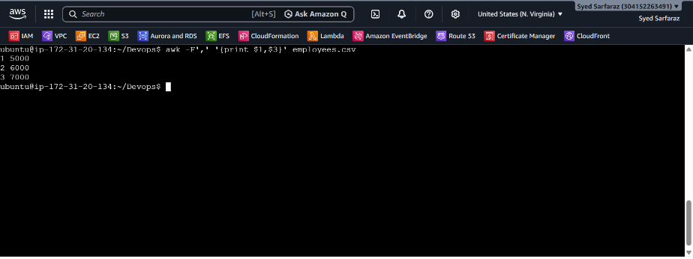

31. Filter and print lines based on a condition
$ awk -F',' '$3 > 5500 {print $0}' employees.csv
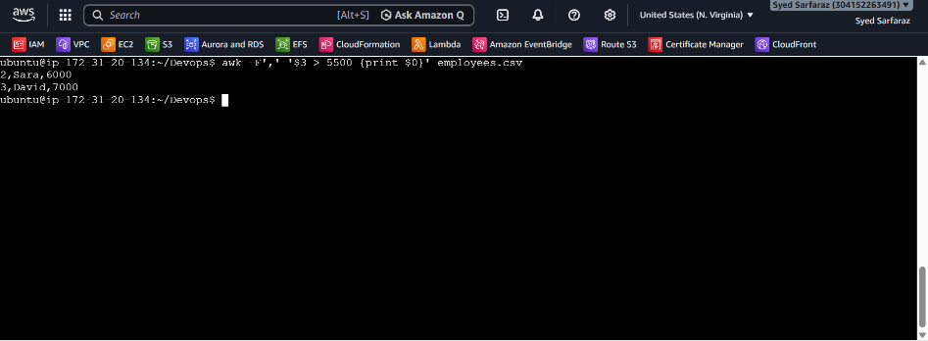

32. Calculate Sum and Average
$ awk -F',' '{sum+=$3} END {print sum}' employees.csv
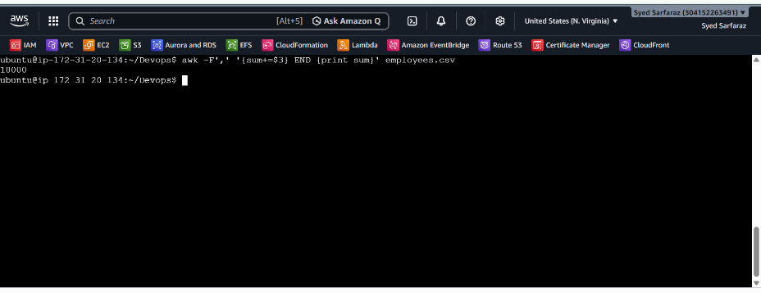
33. String Manipulation
Convert names to Uppercase
$ awk -F',' '{print toupper($2)}' employees.csv
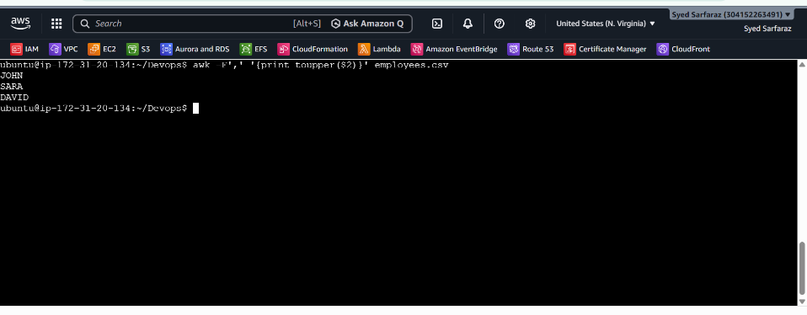
34. Count occurrences of a pattern
$ grep -c "Sara" employees.csv
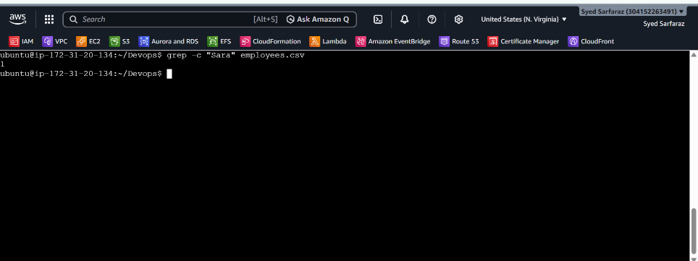

35. Sort lines based on salary column
$ sort -t',' -k3 employees.csv
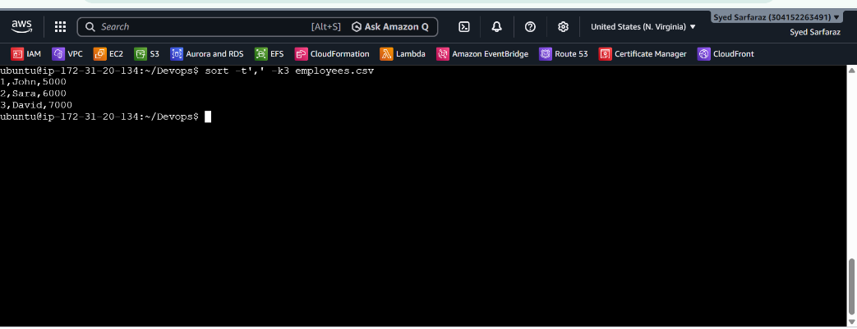

36. Merge multiple files
Convert employees.csv to space-separated file
$ awk -F',' '{print $1,$2,$3}' employees.csv > emp.txt
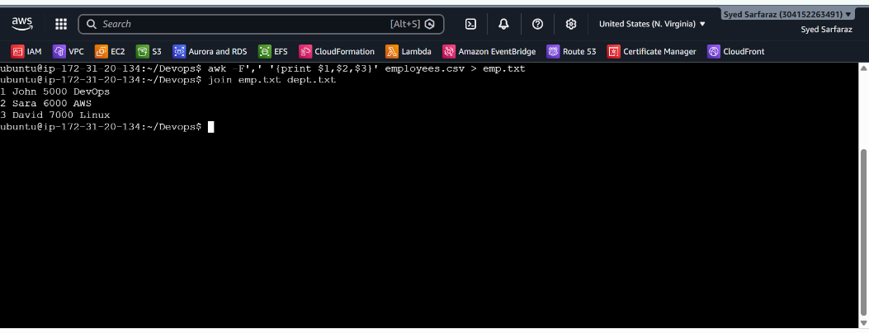

37. Search and Replace
$ sed -i 's/John/Mike/g' employees.csv
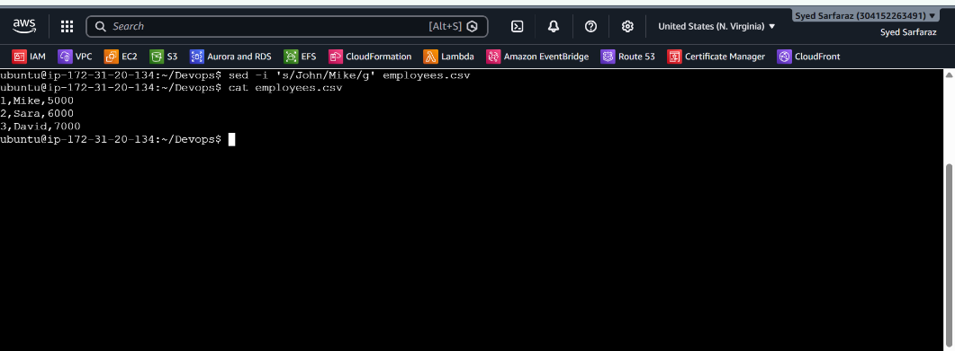
38. Delete specific lines
Delete line number 2
$ sed '2d' employees.csv
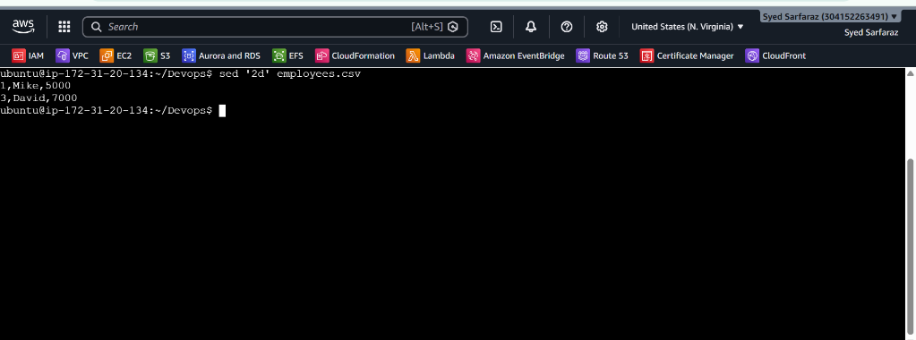
39. Insert and Append Text
Insert before Mike
$ sed '/Mike/i Employee Details' employees.csv
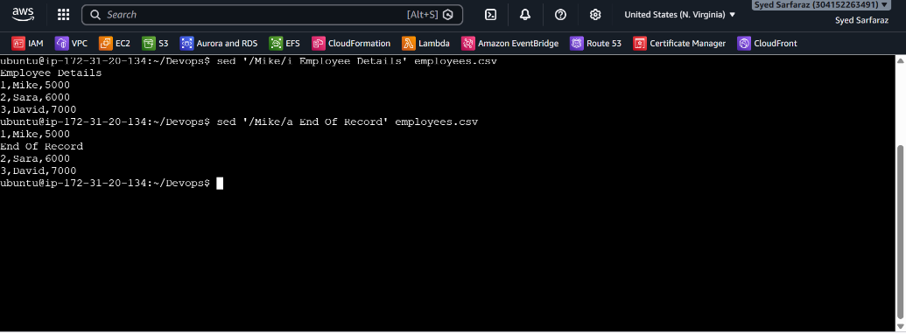
40. Print only specific lines
$ sed -n '1,2p' employees.csv
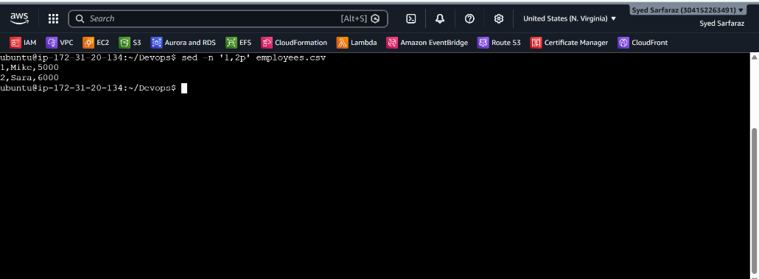

41. Copy file from linux to windows machine
Create a file on Linux (EC2)
$ echo "Hello from AWS Ubuntu" > assignment.txt
$ curl ifconfig.me
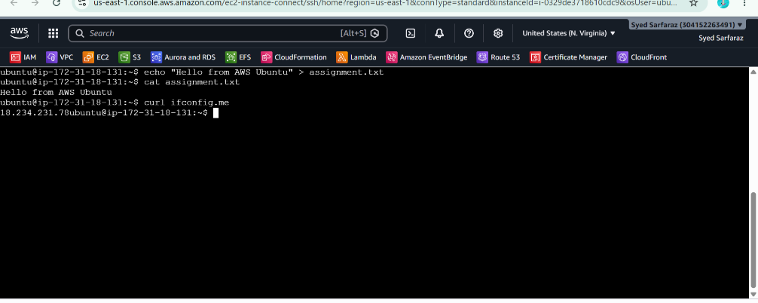
Open PowerShell on Windows
$ scp -i "C:\Users\Pc\Downloads\ubuntu.pem" ubuntu@18.234.231.78:/home/ubuntu/assignment.txt C:\Users\Pc\Desktop\

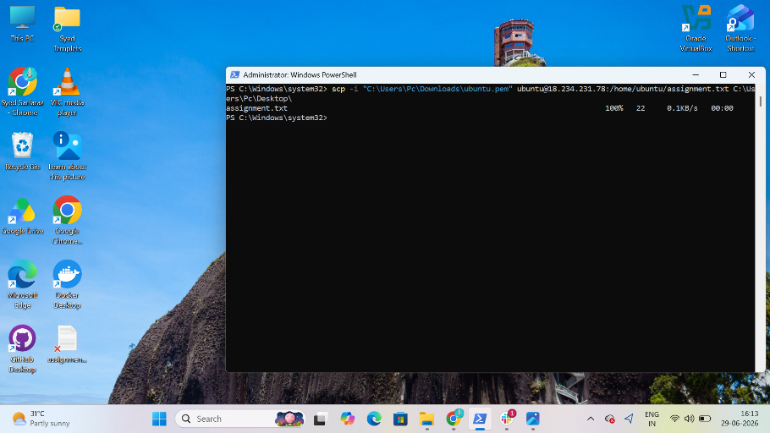

Completed Task of Linux Command’s
- Create user with name Techie and provide sudo access to user.
- Navigate to the home directory.
- Create a new directory.
- List the contents of a directory.
- Change the current directory.
- Create a new empty file.
- View the contents of a file.
- Copy a file to another location.
- Move a file to another location.
- Rename a file.
- Delete a file.
- Grant or revoke permissions on a file or directory.
- View the current date and time.
- Check the system uptime.
- View the running processes.
- Kill a running process.
- Install a package using the package manager (e.g., apt or yum).
- Update the system packages.
- Create a symbolic link.
- Search for files using the find command.
- Compress and decompress files using tar.
- Monitor system resources with top or htop.
- Create and manage user groups.
- Set up SSH password less authentication.
- Monitor log files using tail or grep.
- Set up a web server (e.g., Apache or Nginx).
- Configure and secure a MySQL Database.
- Set up a Application Server (e.g.,Apache Tomcat)
- create a service file for Apache Tomcat.(Should execute by using systemtctl command)
- Print specific columns from a delimited file.
- Filter and print lines based on a specific pattern or condition.
- Calculate and print the average, sum, or other statistics of a column.
- Perform string manipulation, such as extracting substrings or changing case.
- Count the occurrences of a specific pattern in a file.
- Sort lines based on a specific field or column.
- Merge multiple files based on a common field or column.
- Substitute text in a file using search and replace.
- Delete specific lines based on a pattern or line number.
- Append or insert text before or after a specific pattern or line.
- Print only specific lines from a file.
- Copy file from linux to windows machine
- 5 use cases for AWK and 5 use cases for sed

